Designing Video Conference Application for Distance Learning

Mr. Prashanth Kumar SP

Dept. of CSE

Acharya Institute of Technology

Karnataka, India

prashanthkumarsp@acharya.ac.in

Mr. Ajith Padyana

Dept. of CSE

Acharya Institute of Technology

Karnataka, India

ajithpadyana@acharya.ac.in

|  |  |  |
| --- | --- | --- |
|  |  | Aditya Jyoti Sahu  Dept. of CSE  Acharya Institute of Technology  Karnataka, India  adityav.21.becs@acharya.ac.in |
| Anish Kumar  Dept. of CSE  Acharya Institute of Technology  Karnataka, India  anishs.21.becs@acharya.ac.in | Dalavai Hruday  Dept. of CSE  Acharya Institute of Technology  Karnataka, India  dallavid.21.becs@acharya.ac.in | Hanji Ranjan  Dept. of CSE  Acharya Institute of Technology  Karnataka, India  hanjim.21.becs@acharya.ac.in |

*Abstract* **Distance learning system is a real time communication application service used to perform learning process in Internet. The distance learning system application can support text communication, face-to-face communication, dialogue-based communication, and sharing material presentation. The design videoconferencing application for distance learning system consists of three parts, which are a server application program, a moderator application program and a client application program. The importance of the real time communication in organizing distance learning system is its capality to create virtual environment (Internet) as a replication of real world communication, because it supports text communication, file presentation, face-to-face communication and direct dialogue between participants. The face-to-face communication and direct dialogue can create a dynamic interaction environment, because participants can interact face-to-face, directly talk to each other, obtain feedback, present physical reaction of other participants, and chatting using text communication. It become a solution to the problem of distance and time for meeting activities of two or more individuals using internet.**

*Keywords* **Distance learning system, Real time communication, Video conference applica**

1. Introduction

he technology of internet is very useful for all parties, personal, business, government, health, and education environment. This matter causes the technology of internet becomes a necessary to be applied as a communication media which is able to overcome the distance, time, fee and energy problems that is needed to communicate

T

or to interact among human beings.

Various of service video conference applications that is done real time will be develop in the future, to change the conventional of communication environment becomes the communication environment base on internet technology. The real time communication through internet is the communication that is done by two or more participants directly at the same time and in different places.

The importance of real time communication in implementation of long distance learning system is to create virtual world (Internet) as the replica of communication model in the real world. The application of video conference that is done real time can be used to implement the long distance of learning process for support the text communication, presentation file, face to face, and dialogue directly. This matter can create dynamic interaction world because the participants can chatting the text, face to face, speaking directly, and getting feedback directly from another participant, showing the physical reactions and talking the learning material using presentation file.

The application of video conference for long distance learning needs protocol design of layer internet application.

The design of communication protocol at video conference application is needed to arrange the communication processes among the participants so the communication and interaction can be going on as well as. The communication protocol refers to the rules that have been agreed between end system to communicate or to interact by using internet as the communication terminal and the technology of internet as communication media.

If the communication or interaction process among participants is not arranged like the teaching and learning process normally at a classroom, so the effectiveness and the substantial values of long distance learning is not achieved. This matter happens because each participants is free to talk at the time that is wanted by them, is difficult to differentiate the role of participants, the communication is not restrained among the participants, there is conflict between the participants to get speaking right at the learning forum etc.

1. Fundamental Theory

Application of multimedia communication by using text, audio, video and presentation file are the developing of real time interactive of communication model base on internet that will improve in the present and in the future continually. The improving is based on the necessary at the various of application environment, like in the university environment. The university wants to change the learning model, the conventional that is done in a classroom becomes the unreal world (internet) of learning model. Interactive and dynamic of long distance learning model should keep the values that are involved in conventional learning constantly. To achieve it, is needed the planning of multimedia application that supports text communication, face-to-face communication, direct dialogue between the lecturer and the student, and presentation file to convey the learning material. The useful of electronic learning [1] consist of four parts namely:

1. Improving the learning interaction level among the students and the lecturer.
2. Enabling the learning interaction is free to time and location.
3. Reaching the students in big amount to generalize the education and to give the same chance to get knowledge from the experts.
4. Making easy the disseminator, the completing, and the keeping of learning material.

Video conferencing can support the long distance of learning system for face-to-face communication and sound communication. Face-to-face communication and dialog basic can create the interactive and dynamic learning environment. The interactive and dynamic learning environment provides two directions of communication between lecturer and student that is connected by internet as media.

From the result of survey that was done by Chen [2] at standford university can be summarized some lacks of long distance learning that apply face-to-face communication. The lacks are the lecturer can not look the student’s feedback to know whether the material that have been conveyed by lecturer have been understood by students; the student who want to meet with the lecturer has to present in the classroom; and the result of instructor’ experience that suggest the face- to-face interaction is very important to implement the long distance of learning process that interactive and dynamic between the teacher and the students. Dynamic interaction between the lecturer and the student is needed to discuss the problem that is not understood by students directly at the learning process is going on.

The learning process that using video conference can give some advantages like the efficiency of fee for the classroom development and it’s facilities; can become the replica of traditional class for learning process; there is face-to-face communication to interact two directions directly; distribution of knowledge and improving of education quality in remote area because they can get knowledge from the experts that are in another location, and the efficiency of time for the teacher and the students for teaching and learning process that is free at the time and the location.

There are three main tasks performed in videoconferencing sessions [5] :

1. Audio/video distribution. This includes transferring audio and video streams from source clients to destinations in real-time. This is a challenging task, since those streams require high bandwidth and low latency. It is essential to provide an efficient media distribution mechanism that will route media streams through best possible routes from sources to destinations.
2. Media Processing. Media processing is another very important task performed in videoconferencing sessions on server side. Some of the more common ones are audio mixing, video merging, media transcoding, stream monitoring, etc. These tasks usually require high computing resources and real-time output. This requires us to separate media processing units from media distribution units completely to be able to provide scalability.
3. Session management. Session management includes starting/stopping/modifying videoconferencing sessions. It also includes determining and assigning system resources for these sessions. For example, it includes finding out the right audio mixing unit to be used by a meeting. In addition, it includes for participants discovering/joining/leaving sessions. Contrary to the media distribution and media processing tasks, session management requires little bandwidth and computing resources. However, it is very important to coordinate and distribute the tasks in such sessions. Therefore, it is crucial to design a flexible and scalable session management mechanism.

The research that is done by Mingsep [3] design a framework of internet protocol application layer that is mentioned as Inet Application Framework (IAF). The function of IAF is as the framework for development of several communication application because it consist of modules of internet protocol application layer that are generic and independent so can be reused and can be extended according to the user necessary.

The design of IAF architecture consists of elements or components that are needed at real time communication. The role of the components of IAF architecture is as the protocol component to implement the functions of communication among the users of application service. The protocol functions of real time communication are presented in modules form (object classes) of the internet protocol application layer. The protocol modules will be implemented in pustaka class form or program of interface application that can be run in computer.

The components of IAF architecture involve the user interface component, the protocol component of application specific, User Agent server (UAS), User Agent server (UAS), Agent Control Communication (ACC), Location service (LS), and the component of data media (text data, presentation file, audio data and video data). The transmission of audio and video data uses the RTP protocol that is publicized by IETF or the company of Internet Protocol standardization [4]. RTP is the protocol that provides the audio or video data transportation function among end point through internet that is done in real time. The multimedia devices as the supporting of real time communication application such as camera, microphone, speaker, and monitor on each end point computer.

1. Methodology

The research methodology to plan video conferencing application is done through six steps :

* 1. Determining the requirement of long distance of learning system.
  2. Indentifying the role of actors and the responsibility of each actor in implementing of long distance of learning system.
  3. Making the communication scenario in implementing of long distance of learning system.
  4. Arranging the transaction instructions that are needed as identifier of user request in communicating among participants.

Making the design of class diagram to each application program. The design of class diagram involve for server application, moderator application, and client application (the application that is used by lecturer and students).

The planning of application program long distance of learning system as face-to-face for user. The application program of distance learning system consists of three parts namely server application program, moderator application program and client application program.

User

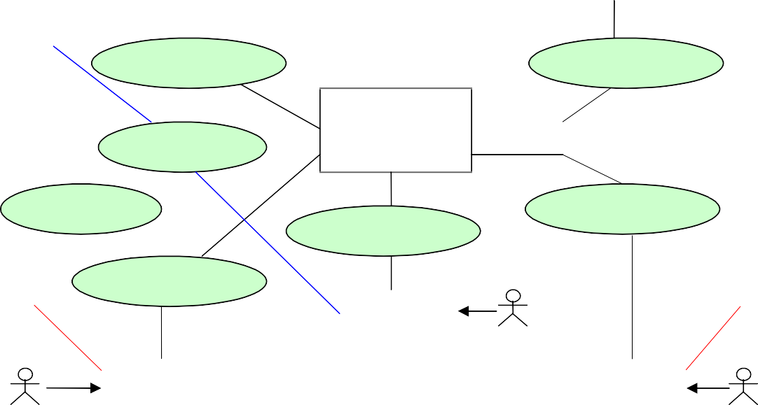

Actual Data (Text, Audio, Video)

Actual Data (Text, Audio, Video)

|  |  |  |
| --- | --- | --- |
| Instructor | |  |
|  |
| Ac | Registration, Login, Signaling, and Logout  Data Aktual (Teks, Audio, Video)  tual Data (Text, Audio, Video)  Registration, Login, Signaling, and Logout | |

User Management

Agent Control Communication (Server)

Registration, Login, Signaling, and Logout

Class Room

Class Room

Registration, Login, Signaling, and Logout

Registration, Login, Signaling, and Logout

User

User

User

Actual Data (Text, Audio, Video)

Figure 1. Model Komunikasi Pada Sistem Pembelajaran Jarak Jauh

Student

Student

User

To plan the video conference application, therefore some aspects those have to be understood as well as possible namely communication model, the responsibility of each actor, communication processes, communication protocol components, the specific rules that is applied at long distance of learning system and the design of user interface. Requirement of distance learning system through internet involves:

1. Distance learning system is used to communicate among lecturer and students. The communication among lecturer and students for teaching and learning process needs text, audio, video, and presentation file communication.
2. Distance learning learning system needs communication service for long distance classroom, for group discussion among students, and private communication service among two users.
3. When the teaching and learning process is going on only one user (lecturer or students) that is allowed to speak, and the other participants as listeners.
4. Distance learning system needs communication model such as one-to-one, one-to-many, and many- to-many. One-to-one communication is used to private communication among two participants, for example the consultation between one student and one teacher. One-to-many communication is used to communicate more than two participants. The distribution of data stream at one-to-many communication is used from one lecturer to all students and only one participant that is allowed to speak at the same time.
5. For speaking in long distance of learning system session that is going on, so each student has to permit to the lecturer. The arranging of communication session in teaching and learning process is done by lecturer as the instructor and the moderator.
6. The communication processes among the participants through internet involve registration, login, signaling, transmission media data, and log out processes.
7. Each user obligates to register and login into long distance of learning system to verify and validate the user.
8. The lecturer and the students are provided face-to- face user (desktop application program) as the communication terminal to interact with another user.
9. Experimental Result

The design of class diagram shows the static structure systematically and collaboration among object classes that is forming the video conference application program to implement the long distance of learning system. The object classes are the publication to objects that present the communication functions and the rules or processes that is needed to communicate real time among the participants through internet. Each object classes have three main areas namely the name of class, class attribute and class method. The design of class diagram at long distance of learning system consist of three parts namely the design of class diagram for server application, the design of class diagram for moderator and the design of class diagram for client application.

Base on the three models of design class diagram, therefore be made video conference application proggram that involve: server application program, moderator application program, and client application program. Each application programs are made in desktop application program form and base on Graphical User Interface. Those application programs are made use platform JDK standard. All of the participants, moderator, lecturer, and students have to do login according to each accsess right of user when the registrate. Login process is useful to validate the user who is allowed to join the long distance of learning process. Among users to do login can be looked at pict. 2 below.

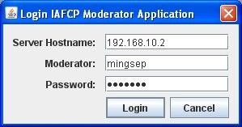

Figure 2. Aplication Program to Login

The Program Planning of Videoconferencing Application consists of three parts, namely:

1. Server application program is used to receive each connection and client as well as to manage or to provide member information that is joining in learning process. Among the server application program is showed in pict. 3 above.
2. Moderator application program is used by lecturer to arrange and manage all the participants for learning process are doing. Among the moderator application program is showed in pict. 4 as follow
3. Client application program is used by lecture and student to communicate in learning process. Among client application program is showed in pict. 5 as follow.

Figure 4. Application Program to Lecturer

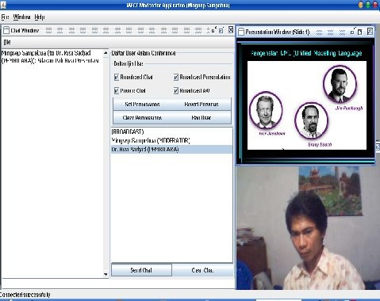

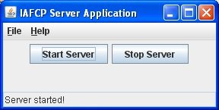

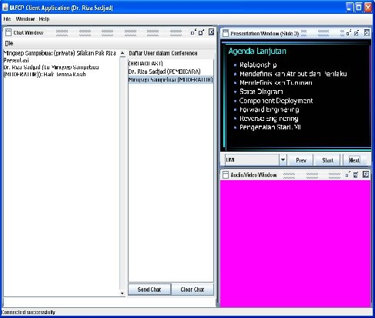Figure3. Application Program to Server

.

1. Conclusions
2. The Program Planning of Videoconferencing Application can be the solution of distance and time problems for lecturer and student in implementing learning process. The lecture and student don’t need to present at a class together, but they can be at different places for it is connected to internet.
3. The Program Planning of Videoconferencing Application for long distance learning consists of three namely server application program, moderator application program, and client application program.
4. The importance of video conference communication in implementation of learning process is to create unreal world (Internet) as the replica of communication style in real world because it supports the chat text communication, face-to-face communication, base dialogue communication, and conveying the learning material through presentation file.

V. References

1. Bates, A. W., and G. Poole, 2003, “Effective Teaching with Technology in Higher Education”, San Fransisco: John Wiley & Son.
2. Chen M., 2003 “Conveying Conversational Cues Through Video”, A Dissertation Submitted to the Department of Electrical Engineering and the Committee Graduated Studies of Standford University in Partial Fulfilment of the Requirement for the Degree of Doctor of Philosophy.
3. Mingsep, Lukito E. Nugroho, Jazi E. Istiyanto, 2010, “The Internet Protocol Design Framework to Real Time Communication Application Development”, Proceedings of The First International Conference On Green Computing, ISSN: 2086-4868, pp. 217-224, Departmen of Electrical Engineering Faculty of Engineering Gadjah Mada University, Yogyakarta.
4. Schulzrinne, H., Casner, S., Frederick, R., and Jacobson, V., 2003, “A Transport Protocol for Real-Time Applications”, RFC 3550, IETF.
5. Uyar A., Wu W., and Fox G., 2005, “Service-Oriented Architecture for Building a Scalable Video conferencing System”, Paper Presented at the IEEE International Conference on Pervasive Services Volume, Issue,

p.445 - 458.